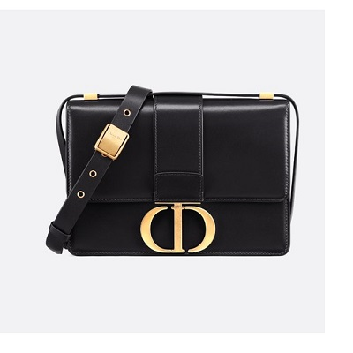

30 Montaigne calfskin bag

PRODUCT DETAILS

**Jewelry in gold-tone metal**

**3 materials: box, supple calfskin on the side, lambskin lining**

**Adjustable leather shoulder strap**

**Textured 30 Montaigne embossing on the back**

**Back pocket**

**Carried on the shoulder or across the body**

**Dimensions: 24 x 17 x 8 cm**